**IBM CAREER EDUCATION**

**MAIN PROJECT**  
**DOMAIN NAME: JAVA**

**TELEPHONE BILLING SYSTEM**

**Submitted By :-**

**Jeet Shah (18162101030)**

**Yash Pendal (18162101026)**

**Dev Punjabi (18082271005)**

**Submitted To:-**

**A. Saai Sanjeev Achaarya**

**IBM Technical Software Trainer**

**TELEPHONE BILLING SYSTEM**

**FLOWCHART**

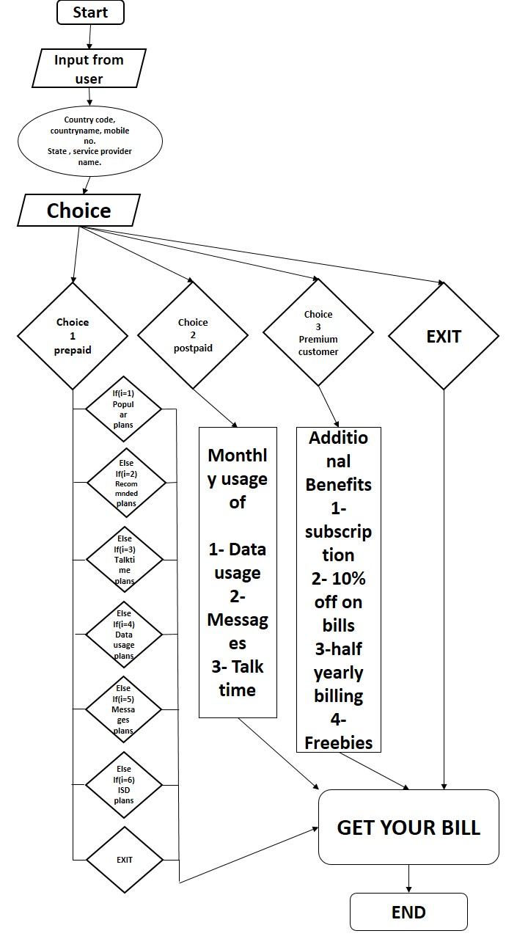

**TELEPHONE BILLING SYSTEM**

**SOFTWARE SPECIFICATIONS**

* OPERATING SYSTEM : LINUX/WINDOWS
* ENVIRONMENT : IBM RAD

**HARDWARE SPECIFICATIONS**

* PROCESSOR : CORE i3 7th Gen
* RAM : 4 GB
* MONITOR : 15 ” BLACK
* HARD DRIVE : 40 GB
* FLOPPY DRIVE : 1.44 MB

**TELEPHONE BILLING SYSTEM**

**DESCRIPTION**

**INTRODUCTION :**

Telephone Billing System in Java is a simple software application developed to improve the efficiency in telephone billing procedures in telecommunication service providers and other suitable organizations. With this system, user billing details can be easily calculated and managed. Overall, a computerized telephone billing system increases the speed of the billing procedure, bill calculation and final report generation.

**DESCRIPTION:**

This Telephone Billing System is a totally computerized system that aims at quick, effective and uncomplicated telephone billing procedure. With this software, the workload for both customers and telecommunication service providers is reduced and the flow of the work is enhanced. More work can be done in lesser time with the new telephone billing system.

Information retrieval, recording and management has become easy and straightforward. As security is given prime importance in this Telephone Billing System, there’s less chance of data mishandling. Also, the software is very easy to use and does not require much skills; a person with basic knowledge of computer can effectively understand the billing procedure incorporated in this software.

**PROS:**

* It can easily be used in combination with other telephone billing subsystems.
* It has consistent interface with high economic options.
* User-friendly; error messages are displayed in a square box on the screen.
* Addition, deletion and editing of existing/new records can be done when required.
* Automatic and fast bill generation.
* Optimized way of paying the telephone bills.
* Day to day usage of this system and thus being user-friendly and also convenient.
* Easy track of previous bills.
* In terms of accessibility it can be accessed anytime anywhere.

**CONS:**

* Everything is dependent on one system.
* Security concerns regarding the data being involved in it.
* Regular tracking is necessary.

**Existing System:**

* All the works in the workspace are done manually.
* It is slow and tedious.
* Adding, editing, deleting or searching for records in the files/registers is slow.
* Maintenance and handling of works of large volume is cumbersome in itself.
* The existing system is very error-prone.
* Updating is difficult and may require new registers/files in most cases.

**TELEPHONE BILLING SYSTEM**

**PICTURES**

**Telephone /Mobiles**

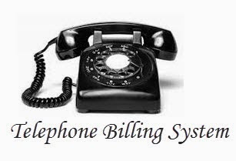

**Pay anytime & anywhere**

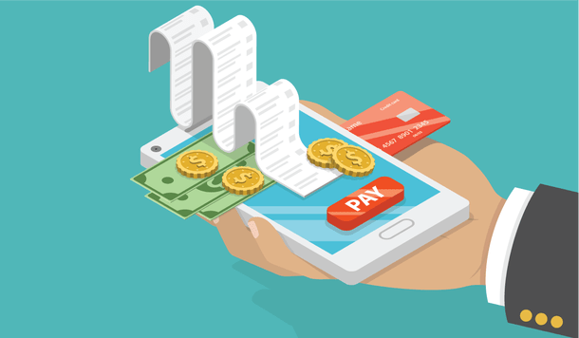

**PICTURES**

**File System to Computerized System**

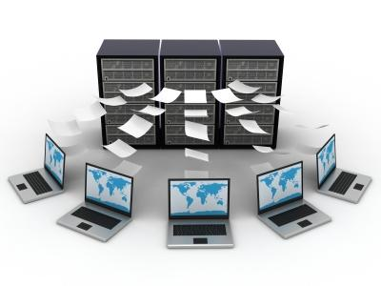

**Stay updated every time**

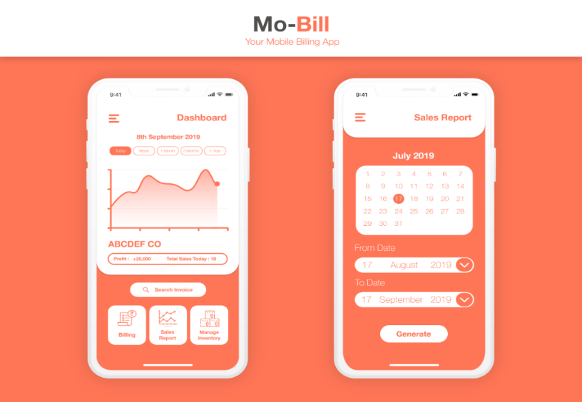

**CODE:**

**import java.util.*;**

**class base**

**{**

**int a,n,amount=0;**

**String c_name;**

**int c_code;**

**long u_p_num;**

**String u_state;**

**String u_pd_name;**

**String sim_type;**

**String s1="Airtel";**

**String s2="Bsnl";**

**String s3="Jio";**

**String s4="Vodafone";**

**void putdata()**

**{**

**Scanner sc = new Scanner(System.in);**

**System.out.println("------------------------------------------");**

**System.out.println(" ");**

**System.out.println(" Telephone Billing System ");**

**System.out.println(" ");**

**System.out.println("------------------------------------------");**

**System.out.println("\n Enter the Country Name :- ");**

**c_name = sc.next();**

**System.out.println("\n Enter the Country Code :- ");**

**System.out.print("+");**

**c_code = sc.nextInt();**

**System.out.println("\n Enter the Customer Mobile Number :- ");**

**System.out.print("+"+c_code );**

**u_p_num = sc.nextLong();**

**System.out.println("\n Enter the State Name :- ");**

**u_state = sc.next();**

**System.out.print("Your state "+u_state);**

**System.out.print(" has following service providers. Choose any one of these: ");**

**System.out.println("1.Airtel");**

**System.out.println("2.Bsnl");**

**System.out.println("3.Jio");**

**System.out.println("4.Vodafone");**

**System.out.println("\n Enter the Service Provider Name :- ");**

**u_pd_name = sc.next();**

**/*if(u_pd_name == s1 || u_pd_name == s2 || u_pd_name == s3 || u_pd_name == s4 );**

**{*/**

**System.out.println("\n Enter the Choice : ");**

**System.out.println("Press 1 for Post Paid.");**

**System.out.println("Press 2 for Pre Paid.");**

**System.out.println("Press 3 to become our Premium Customer.");**

**System.out.println("Press 4 for the Feedback.");**

**System.out.println("Press 5 to exit.");**

**a = sc.nextInt();**

**switch(a)**

**{**

**case 1:**

**sim_type = "Post Paid";**

**System.out.println("\nThe code for your Post-Paid plan was PP01.");**

**System.out.println("The plan included of 75GB with rollover + Free UNLIMITED calling + No roaming charges + upto 100 SMS per day.");**

**System.out.println("You have used 61.76GB of which the remaining 13.24GB will get rollover to the next month.\n You also had talktime of 3000 minutes and an average of 20 messages per day. ");**

**System.out.println("The monthly rent for the same is stated at Rs.499 for the month of September.");**

**System.out.println("The due date of the bill is on 20/10/2019.");**

**System.out.println("*If not paid before the due date additional charges may apply as per the terms and conditions of it.");**

**amount = amount + 499;**

**break;**

**case 2 :**

**sim_type = "Pre Paid";**

**System.out.println("\nThe code for your Pre-Paid plan was PR01.");**

**System.out.println("The plan included of 1.5GB per day with no rollover + Free UNLIMITED calling + No roaming charges + upto 100 SMS per day.");**

**System.out.println("The validity of it is for 28 days.");**

**System.out.println("You will get updated of daily usage at 50% also at 90% and at 100%");**

**System.out.println("After completion of daily limit the speed for data usage gets reduced.");**

**System.outprintln("The data usage speed limit gets renewed when the day changes.");**

**case 3 :**

**sim_type = "Post-Paid (Exclusively)";**

**break;**

**case 4 :**

**System.out.println("Welcome to the FEEDBACK Section");**

**case 5 :**

**System.out.println("\n Exit ");**

**default:**

**System.out.println("Wrong input");**

**}**

**}**

**}**

**void showdata()**

**{**

**System.out.println("\n _ _ _ _ _ _ _ _ _ _ _ _ _ _ _ _ _ _ _ _ _ _ _ _ _ _ _ _ _ _ _* TELEPHONE BILL *_ _ _ _ _ _ _ _ _ _ _ _ _ _ _ _ _ _ _ _ _ _ _ _ _ _ _ _ _ _ _ _");**

**System.out.print("\n |Country Name :- "+ c_name );**

**System.out.println("\t\t\t\t\t\t\t\t\t\t\t\t\t\t\t|");**

**System.out.println("\n | |");**

**System.out.print("\n |Country Code :- +"+ c_code);**

**System.out.println("\t\t\t\t\t\t\t\t\t\t\t\t\t\t\t|");**

**System.out.println("\n | |");**

**System.out.print("\n |Customer Mobile Number : " + c_code);**

**System.out.print(" "+ u_p_num);**

**System.out.println("\t\t\t\t\t\t\t\t\t\t\t\t\t |");**

**System.out.println("\n | |");**

**System.out.print("\n |State Name :- " + u_state);**

**System.out.println("\t\t\t\t\t\t\t\t\t\t\t\t\t\t|");**

**System.out.println("\n | |");**

**System.out.print("\n |Service Provider Name :- " + u_pd_name);**

**System.out.println("\t\t\t\t\t\t\t\t\t\t\t\t\t\t|");**

**System.out.println("\n | |");**

**System.out.print("\n |Customer Service Plan Type :- " + sim_type);**

**System.out.println("\t\t\t\t\t\t\t\t\t\t\t\t\t\t|");**

**System.out.println("\n |_ _ _ _ _ _ _ _ _ _ _ _ _ _ _ _ _ _ _ _ _ _ _ _ _ _ _ _ _ _ _ _ _ _ _ _ _ _ _ _ _ _ _ _ _ _ _ _ _ _ _ _ _ _ _ _ _ _ _ _ _ _ _ _ _ _ _ _ _ _ _ |");**

**}**

**}**

**class project**

**{**

**public static void main(String[] args)**

**{**

**base b = new base();**

**b.putdata();**

**b.showdata();**

**}**

**}**

**OUTPUT:**

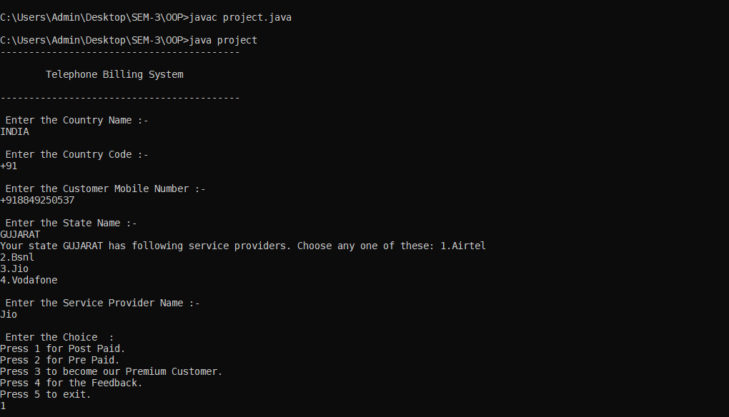

**Figure:1**

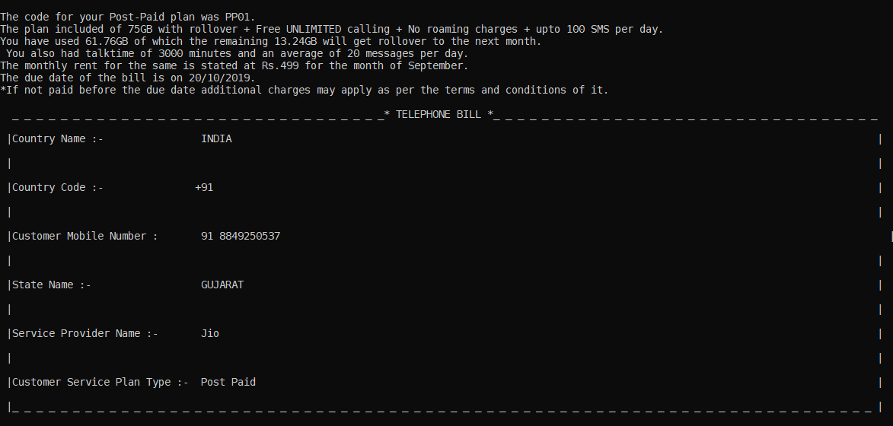

**Figure:2**

**TELEPHONE BILLING SYSTEM**

**References –**

1. Google Images
2. Geeks for geeks
3. Codewithc.com

**Conclusion:**

To overcome the drawbacks and complexities of the existing system, this Telephone Billing System Project in Java platform was proposed. It eliminates the need of registers and files in many cases as the proposed system is fully computerized. It is quick, user-friendly and accurate, and does not create complications in telephone billing and management process.